Version 1.0

Revision History

|  |  |  |  |
| --- | --- | --- | --- |
| **Date** | **Version** | **Description** | **Author** |
| 15/12/2019 | 1.0 | details | Phạm Thị Hồng Trang |
|  |  |  |  |
|  |  |  |  |
|  |  |  |  |

Table of Contents

1. Introduction 2

1.1 Purpose 2

1.2 Scope 2

1.3 Definitions, Acronyms, and Abbreviations 2

1.4 References 2

1.5 Overview 2

2. Flow of Events—Design 2

3. Derived Requirements 2

# Introduction

## Purpose

This document describes how the Add to Shopping Cart Use-Case is realized within the design model, in terms of collaborating objects

## Scope

This document applies to the Computer Shop System which will be developed by CT Computer

## Definitions, Acronyms, and Abbreviations

User – a person who use the system, can be customer or employee.

## References

None

## Overview

In the following section, Use-Case Realization Specification of the Order Computers Use-Case of the Computer Shop System is provided in detail. The first section is a textual description of the Use-Case specification. The following section contains diagrams (sequence diagrams) describing how the use case is realized in terms of collaborating objects. The third section includes class diagrams with relationships that participate in the realization of the use case. The last section is an analysis of all requirements, such as non-functional requirements, on the use-case realization that are not considered in the design model, but that need to be taken care of during implementation.

# Flow of Events—Design

**Sequence Diagram:**

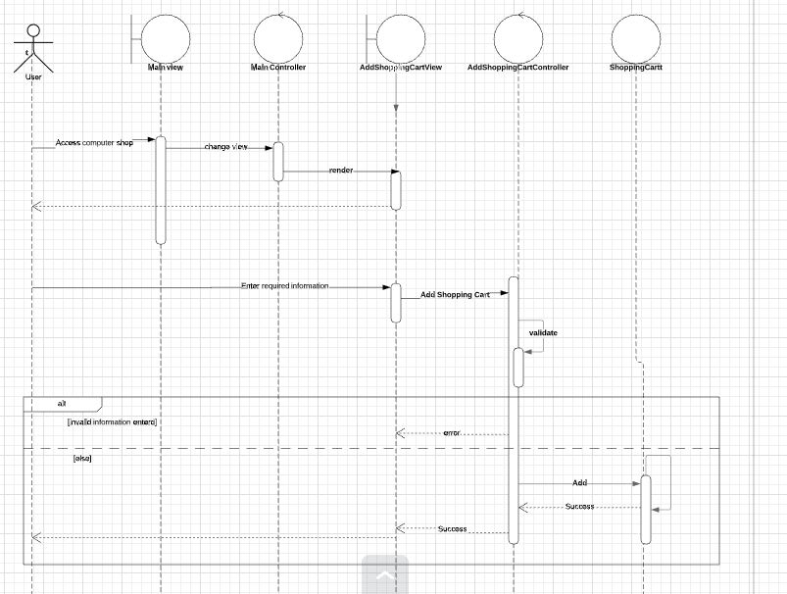

Class Diagram

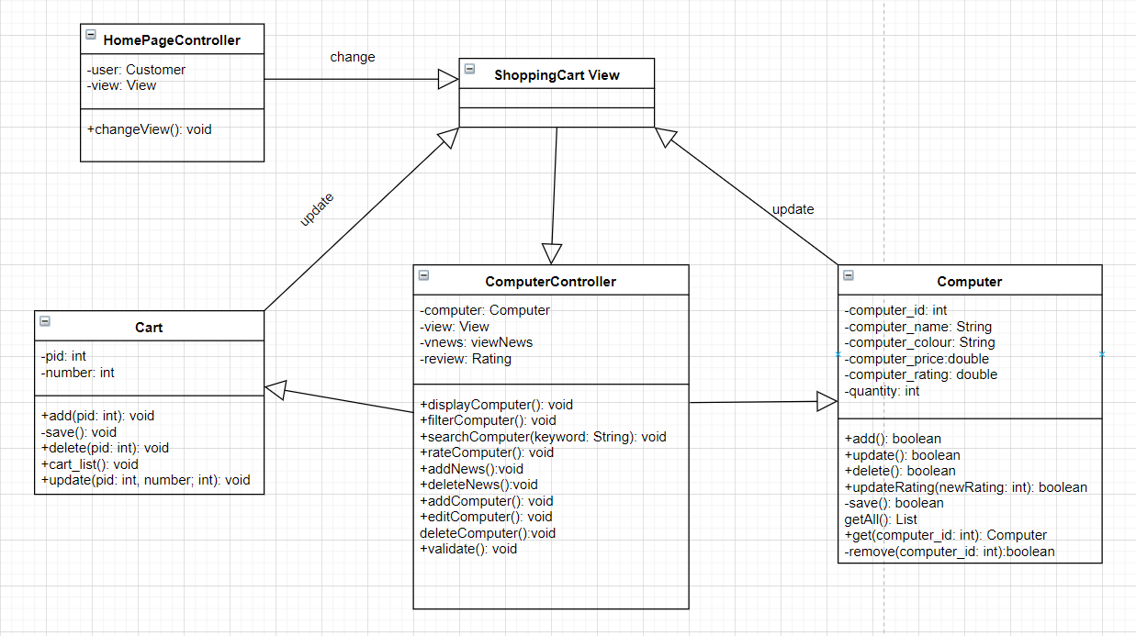

# Derived Requirements

None